- Minimum Moves to Make Array Complementary

Question :[ https://leetcode.com/problems/minimum-moves-to-make-array-complementary/submissions/2002202898/?envType=daily-question&envId=2026-05-13 ]

Solution :

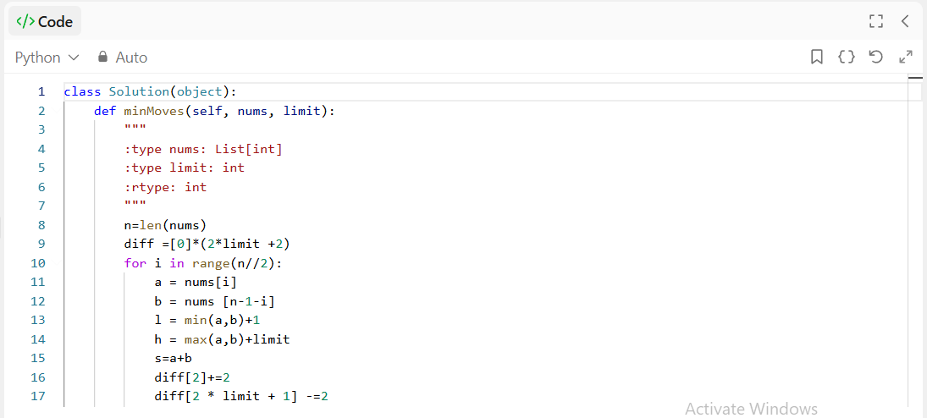



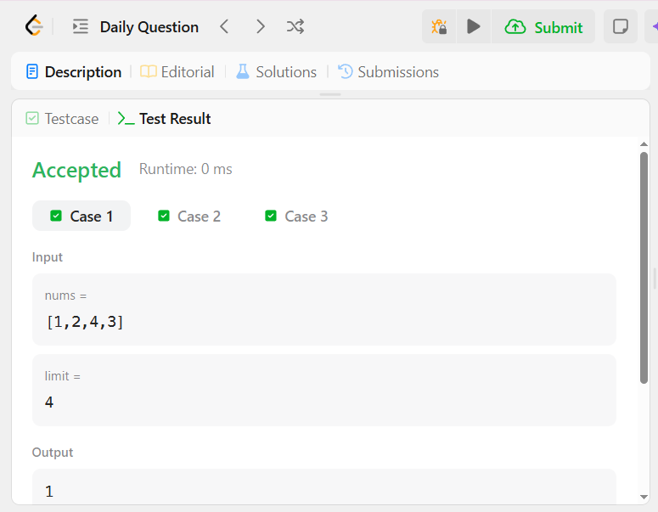



Time & Space Complexity
Time is O(n+limit)
Space : O(limit)

